Name: Date:

|  |  |
| --- | --- |
|  | Meet Pirate Pete. Help Pete explore the island and find his treasure. Write down the co-ordinates of all the places Pete visits. |

|  |  |  |
| --- | --- | --- |
| Move Pirate Pete around the island to each of the following places. | Write down the co-ordinates (e.g A,1) | |
| First Pete heads out to Shark Bay. |  | |
| Then he travels to lighthouse point. |  | |
| He journeys all the way along the Rocky Ridge from north to south. | North point | South point |
|  |  |
| He rests a while in the Beach hut… |  | |
| … before making his way to the Vile Volcano! |  | |
| He swims out to Shipwreck Bay to see if he can find his ship. |  | |
| Then takes a dip in Frog point swimming from east to west | East point | West point |
|  |  |
| He heads to the middle of the Forest of Gloom but still no sign of his treasure. |  | |
| Finally he spots the treasure marked with an X! |  | |

Answers

|  |  |  |
| --- | --- | --- |
| Move Pirate Pete around the island to each of the following places. | Write down the co-ordinates (e.g A,1) | |
| First Pete heads out to Shark Bay. | **(H,9)** | |
| Then he travels to lighthouse point. | **(K,9)** | |
| He journeys all the way along the Rocky Ridge from north to south. | North point | South point |
| **(G,7)** | **(G,6)** |
| He rests a while in the Beach hut… | **(H,4)** | |
| … before making his way to the Vile Volcano! | **(F,3)** | |
| He swims out to Shipwreck Bay to see if he can find his ship. | **(D,2)** | |
| Then takes a dip in Frog point swimming from east to west | East point | West point |
| **(D,5)** | **(E,5)** |
| He heads to the middle of the Forest of Gloom but still no sign of his treasure. | **(D,7)** | |
| Finally he spots the treasure marked with an X! | **(F,9)** | |



Meet Pirate Pete

**Help Pete explore the island and find his treasure!**

**Write down the co-ordinates of all the places Pete visits, using the worksheet to guide you.**

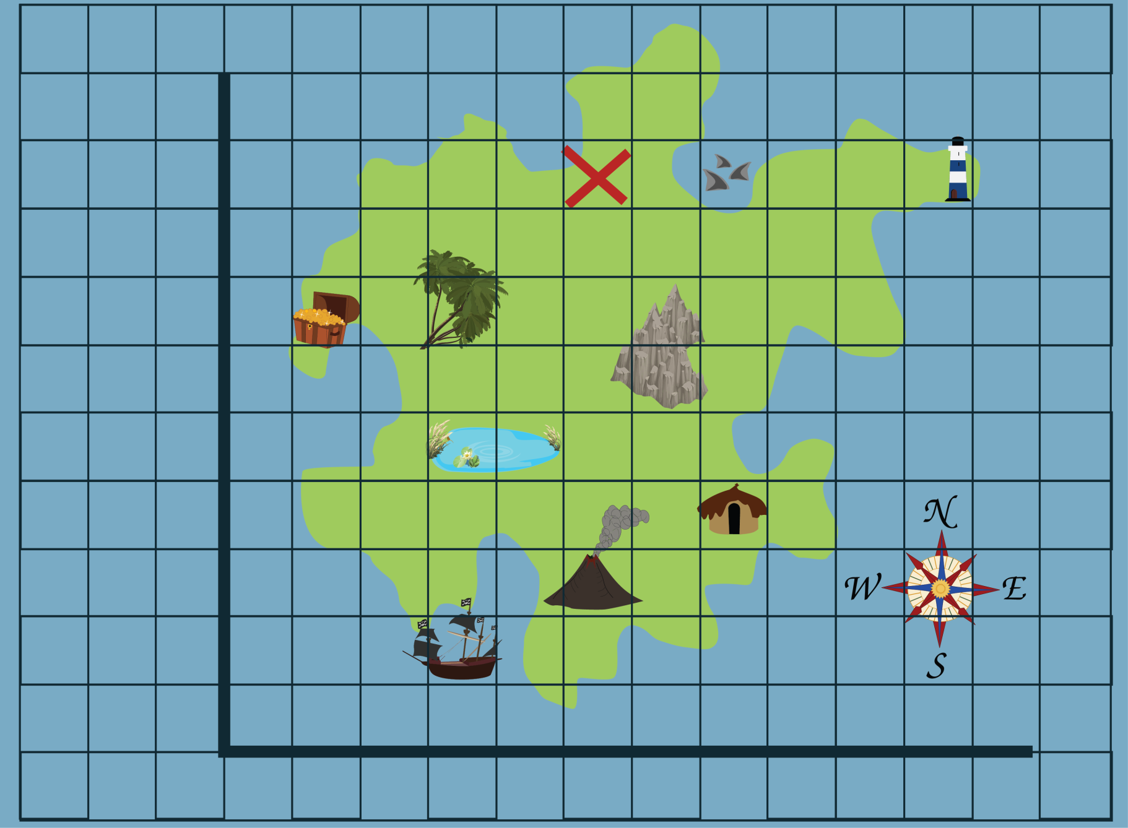

**1**

**2**

**3**

**4**

**5**

**6**

**7**

**8**

**9**

**10**

**0**

**A**

**B**

**C**

**D**

**E**

**F**

**G**

**H**

**I**

**J**

**K**

**L**

**M**

Meet Pirate Pete