Name: Date:

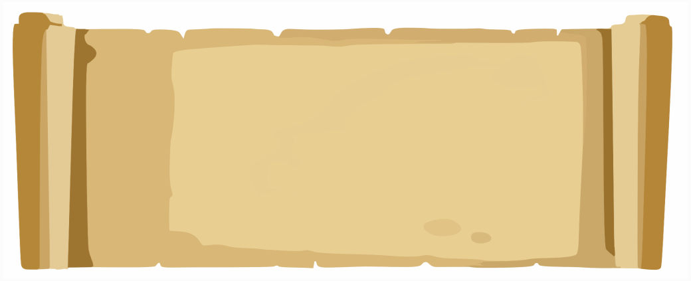
Meet Pirate Pete. Help Pete explore the island and find his treasure. Write down the co-ordinates of all the places Pete visits.

Move Pirate Pete around the island to each of the following places. | Write down the co-ordinates (e.g A,1)
First Pete heads out to Shark Bay.
Then he travels to lighthouse point.
He journeys all the way along the Rocky Ridge from north to south. | North point | South point
He rests a while in the Beach hut…
… before making his way to the Vile Volcano!
He swims out to Shipwreck Bay to see if he can find his ship.
Then takes a dip in Frog point swimming from east to west | East point | West point
He heads to the middle of the Forest of Gloom but still no sign of his treasure.
Finally he spots the treasure marked with an X!

Answers

Move Pirate Pete around the island to each of the following places. | Write down the co-ordinates (e.g A,1)
First Pete heads out to Shark Bay. | (H,9)
Then he travels to lighthouse point. | (K,9)
He journeys all the way along the Rocky Ridge from north to south. | North point | South point
 | (G,7) | (G,6)
He rests a while in the Beach hut… | (H,4)
… before making his way to the Vile Volcano! | (F,3)
He swims out to Shipwreck Bay to see if he can find his ship. | (D,2)
Then takes a dip in Frog point swimming from east to west | East point | West point
Then takes a dip in Frog point swimming from east to west | (D,5) | (E,5)
He heads to the middle of the Forest of Gloom but still no sign of his treasure. | (D,7)
Finally he spots the treasure marked with an X! | (F,9)



Meet Pirate Pete
Help Pete explore the island and find his treasure!
Write down the co-ordinates of all the places Pete visits, using the worksheet to guide you.
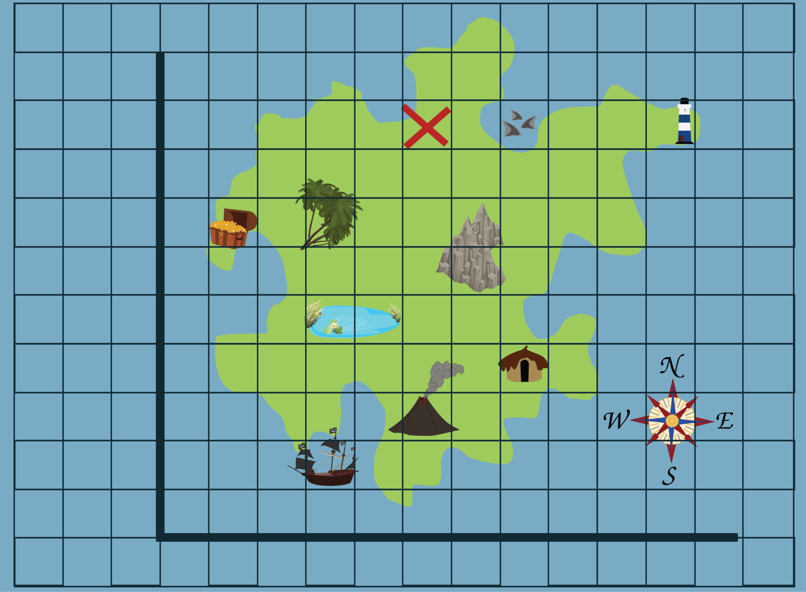
1
2
3
4
5
6
7
8
9
10
0
A
B
C
D
E
F
G
H
I
J
K
L
M
Meet Pirate Pete

