Name: Date:

Read these word problems and then answer the questions. Remember to show your workings out.

Cinderella’s ugly sisters have 64 dresses, but throw away 27 of them. How many do they have left? |  |  | The Wicked Queen has 32 poisoned apples in her basket, but drops 12. How many does she have left? | 
Hansel took a bag of 56 pebbles. He dropped 39 of them on the path. How many did he have left? |  |  | Hansel ate 16 pieces of gingerbread and Gretel ate 18. How many did they eat altogether? | 
The Queen put 16 mattresses on the princess’s bed and then added another 26. How many were there altogether? | 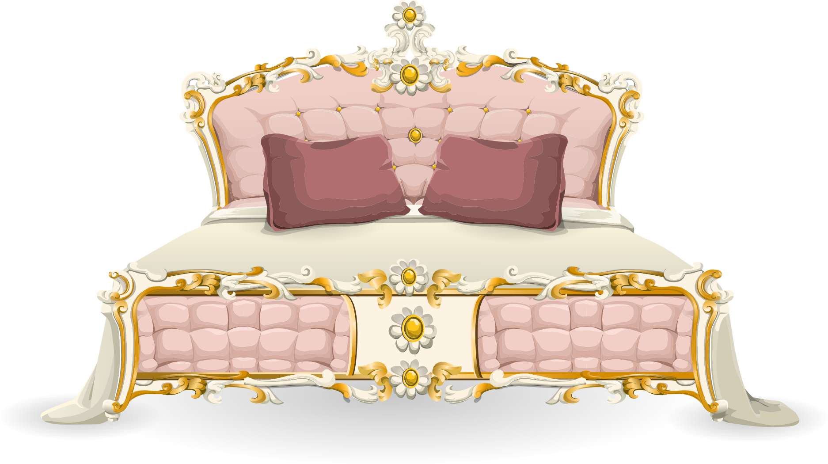 |  | The Wicked Queen made 50 ml of a potion to change the way that she looked. She drank 34 ml of it. How much was left? | 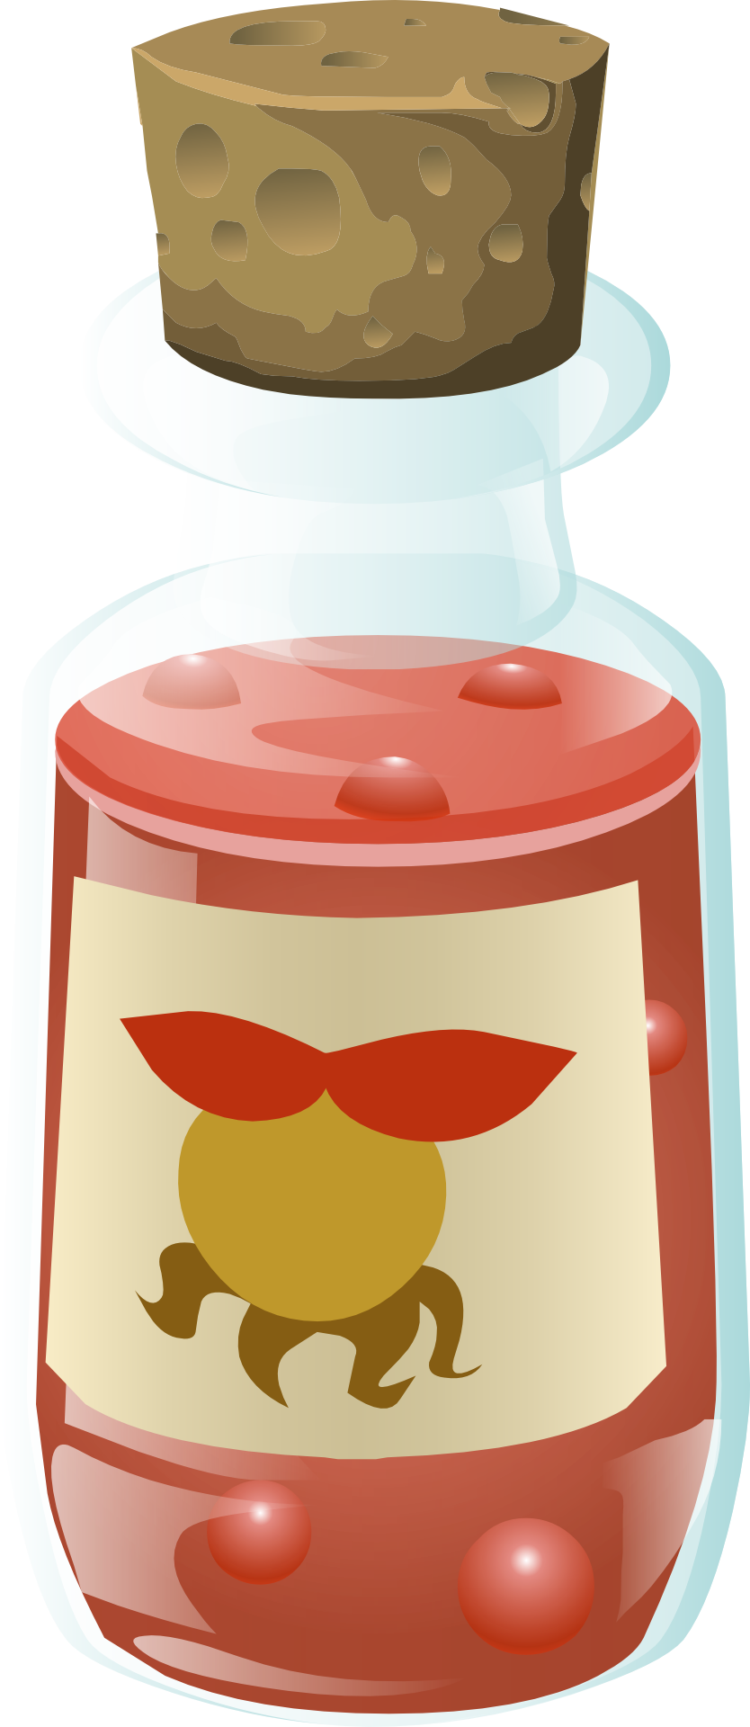
The Frog Prince lived in the pond for 150 days and the stream for 350 days before he was turned into a prince. How long was he a frog for? |  |  | Little Red Riding Hood baked 23 cakes, 14 biscuits and 2 pies to take to Grandma and put them in her basket. How many things did she put in her basket? | 

Answers

Fairy tale problems (set 1)

- Cinderella’s ugly sisters have 64 dresses, but throw away 27 of them. How many do they have left?

37 dresses

- The Wicked Queen has 32 poisoned apples in her basket, but drops 12. How many does she have left?

20 apples

- Hansel took a bag of 56 pebbles. He dropped 39 of them on the path. How many did he have left?

17 pebbles

- Hansel ate 16 pieces of gingerbread and Gretel ate 18. How many did they eat altogether?

34 pieces of gingerbread

- The Queen put 16 mattresses on the princess’s bed and then added another 26. How many were there altogether?

42 mattresses

- The Wicked Queen made 50 ml of a potion to change the way that she looked. She drank 34 ml of it. How much was left?

16ml

- The Frog Prince lived in the pond for 150 days and the stream for 350 days before he was turned into a prince. How long was he a frog for?

500 days

- Little Red Riding Hood baked 23 cakes, 14 biscuits and 2 pies to take to Grandma and put them in her basket. How many things did she put in her basket?

39 things

