Sports Grant Calculations:

After School Sports Clubs and after school tournament matches:
Staff member @ £23.12 p/hour x 3 clubs/matches per week = £69.36pp/week x 38 weeks per year = £2635.68
Staff member @ £13.97p/hour x 3 clubs/matches per week = £41.91p/week x 38 weeks per year = £1592.58

Total for extra curricular activities = £4228.26. 2/3 of this cost on clubs provided by WJS £2818.84 and 1/3 on sporting competitions and external league matches £1409.42

Minibus lease is: £14209.44 per year
Minibus servicing and petrol totals per year: £1800 (£100 per term on diesel - £600 per year and £100 per month servicing costs - £1200 per year)

Total minibus costs = £16009.44 – 2/3 of this cost is used on travel to sporting activities £10672.96

Resources:

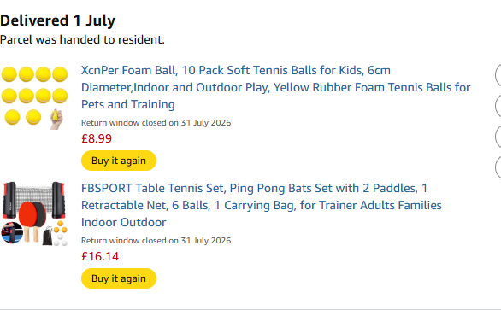

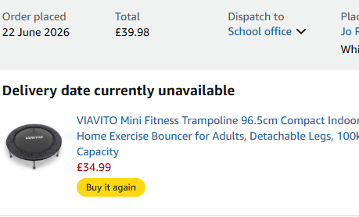

Resources total £97.60

Sports professional services brought into school:
Skip To Be Fit = £702.00
Wimbledon tickets for pupils = £275
Faversham Town Football Coaching - £50.00

Total extra curricular bought in services = £1027

Swimming Costs:

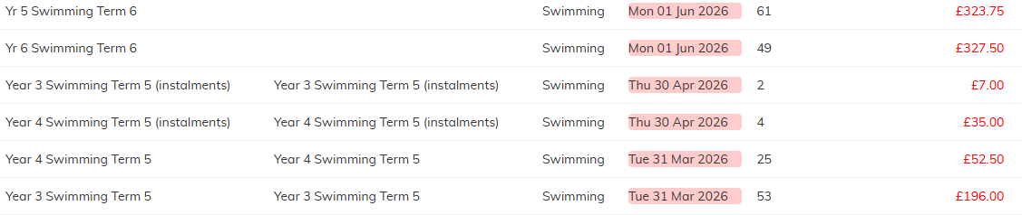
Total cost of swimming for PP children = £941.75
Swimming Stats:
Total Year 6 Swimmers | 49 | 100%
Non 25m Swimmers | 5 | 10%
Successful 25m Swimmers | 44 | 90%
Swimmers using a range of strokes | 13 | 27%
Self Rescue Swimmers | 13 | 27%

Total sporting costs Academic year = £16967.57



